**EECS 495 Biometrics**

**Assignment 2: Iris Segmentation**

|  |  |
| --- | --- |
| **Group Member:** | **Net ID:** |
| **Haikun Liu** | **hlg483** |
| **Ke Wang** | **kwp862** |
| **Weishen Chu** | **wci004** |

1. A toy example of edge pixels of an iris image. Please detect the circle boundary with r = 3 pixels using Hough Transform i.e. show the hough space voting process and plot the fitted circle on the original edge image.

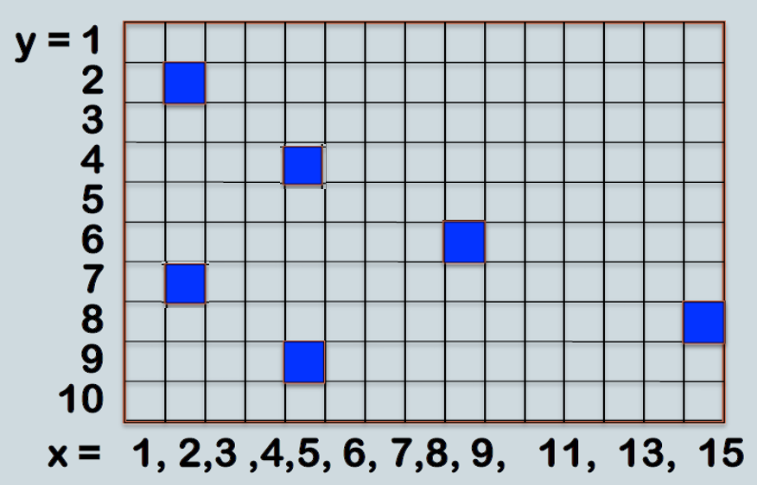

**Step 1. Center = (2,2), Accumulate = (4,4)**

|  |  |  |  |  |  |  |  |  |  |  |  |  |  |  |
| --- | --- | --- | --- | --- | --- | --- | --- | --- | --- | --- | --- | --- | --- | --- |
|  |  |  |  |  |  |  |  |  |  |  |  |  |  |  |
|  |  |  |  |  |  |  |  |  |  |  |  |  |  |  |
|  |  |  |  |  |  |  |  |  |  |  |  |  |  |  |
|  |  |  | 1 |  |  |  |  |  |  |  |  |  |  |  |
|  |  |  |  |  |  |  |  |  |  |  |  |  |  |  |
|  |  |  |  |  |  |  |  |  |  |  |  |  |  |  |
|  |  |  |  |  |  |  |  |  |  |  |  |  |  |  |
|  |  |  |  |  |  |  |  |  |  |  |  |  |  |  |
|  |  |  |  |  |  |  |  |  |  |  |  |  |  |  |
|  |  |  |  |  |  |  |  |  |  |  |  |  |  |  |

**Step 2. Center = (2,7), Accumulator = (4,5) (5,6) (5,7)**

|  |  |  |  |  |  |  |  |  |  |  |  |  |  |  |
| --- | --- | --- | --- | --- | --- | --- | --- | --- | --- | --- | --- | --- | --- | --- |
|  |  |  |  |  |  |  |  |  |  |  |  |  |  |  |
|  |  |  |  |  |  |  |  |  |  |  |  |  |  |  |
|  |  |  |  |  |  |  |  |  |  |  |  |  |  |  |
|  |  |  | 1 |  |  |  |  |  |  |  |  |  |  |  |
|  |  |  | 1 |  |  |  |  |  |  |  |  |  |  |  |
|  |  |  |  | 1 |  |  |  |  |  |  |  |  |  |  |
|  |  |  |  | 1 |  |  |  |  |  |  |  |  |  |  |
|  |  |  |  |  |  |  |  |  |  |  |  |  |  |  |
|  |  |  |  |  |  |  |  |  |  |  |  |  |  |  |
|  |  |  |  |  |  |  |  |  |  |  |  |  |  |  |

**Step 3. Center = (5,4), Accumulator = (8,4) (8,5) (7,6) (6, 7) (5,7) (4,7)**

|  |  |  |  |  |  |  |  |  |  |  |  |  |  |  |
| --- | --- | --- | --- | --- | --- | --- | --- | --- | --- | --- | --- | --- | --- | --- |
|  |  |  |  |  |  |  |  |  |  |  |  |  |  |  |
|  |  |  |  |  |  |  |  |  |  |  |  |  |  |  |
|  |  |  |  |  |  |  |  |  |  |  |  |  |  |  |
|  |  |  | 1 |  |  |  | 1 |  |  |  |  |  |  |  |
|  |  |  | 1 |  |  |  | 1 |  |  |  |  |  |  |  |
|  |  |  |  | 1 |  | 1 |  |  |  |  |  |  |  |  |
|  |  |  | 1 | 2 | 1 |  |  |  |  |  |  |  |  |  |
|  |  |  |  |  |  |  |  |  |  |  |  |  |  |  |
|  |  |  |  |  |  |  |  |  |  |  |  |  |  |  |
|  |  |  |  |  |  |  |  |  |  |  |  |  |  |  |

**Step4. Center = (5,9), Accumulator = (4, 6) (5,6) (6,6) (7,7)**

|  |  |  |  |  |  |  |  |  |  |  |  |  |  |  |
| --- | --- | --- | --- | --- | --- | --- | --- | --- | --- | --- | --- | --- | --- | --- |
|  |  |  |  |  |  |  |  |  |  |  |  |  |  |  |
|  |  |  |  |  |  |  |  |  |  |  |  |  |  |  |
|  |  |  |  |  |  |  |  |  |  |  |  |  |  |  |
|  |  |  | 1 |  |  |  | 1 |  |  |  |  |  |  |  |
|  |  |  | 1 |  |  |  | 1 |  |  |  |  |  |  |  |
|  |  |  | 1 | 2 | 1 | 1 |  |  |  |  |  |  |  |  |
|  |  |  | 1 | 2 | 1 | 1 |  |  |  |  |  |  |  |  |
|  |  |  |  |  |  |  |  |  |  |  |  |  |  |  |
|  |  |  |  |  |  |  |  |  |  |  |  |  |  |  |
|  |  |  |  |  |  |  |  |  |  |  |  |  |  |  |

**Step 5. Center = (9,6), Accumulator = (7,4) (6,5) (6, 6) (6,7) (11,4) (12,5) (12,6) (12,7)**

|  |  |  |  |  |  |  |  |  |  |  |  |  |  |  |
| --- | --- | --- | --- | --- | --- | --- | --- | --- | --- | --- | --- | --- | --- | --- |
|  |  |  |  |  |  |  |  |  |  |  |  |  |  |  |
|  |  |  |  |  |  |  |  |  |  |  |  |  |  |  |
|  |  |  |  |  |  |  |  |  |  |  |  |  |  |  |
|  |  |  | 1 |  |  | 1 | 1 |  |  | 1 |  |  |  |  |
|  |  |  | 1 |  | 1 |  | 1 |  |  |  | 1 |  |  |  |
|  |  |  | 1 | 2 | 2 | 1 |  |  |  |  | 1 |  |  |  |
|  |  |  | 1 | 2 | 2 | 1 |  |  |  |  | 1 |  |  |  |
|  |  |  |  |  |  |  |  |  |  |  |  |  |  |  |
|  |  |  |  |  |  |  |  |  |  |  |  |  |  |  |
|  |  |  |  |  |  |  |  |  |  |  |  |  |  |  |

**Step 6. Center = (15,8), Accumulator = (12,7)**

|  |  |  |  |  |  |  |  |  |  |  |  |  |  |  |
| --- | --- | --- | --- | --- | --- | --- | --- | --- | --- | --- | --- | --- | --- | --- |
|  |  |  |  |  |  |  |  |  |  |  |  |  |  |  |
|  |  |  |  |  |  |  |  |  |  |  |  |  |  |  |
|  |  |  |  |  |  |  |  |  |  |  |  |  |  |  |
|  |  |  | 1 |  |  | 1 | 1 |  |  | 1 |  |  |  |  |
|  |  |  | 1 |  | 1 |  | 1 |  |  |  | 1 |  |  |  |
|  |  |  | 1 | 2 | 2 | 1 |  |  |  |  | 1 |  |  |  |
|  |  |  | 1 | 2 | 2 | 1 |  |  |  |  | 2 |  |  |  |
|  |  |  |  |  |  |  |  |  |  |  |  |  |  |  |
|  |  |  |  |  |  |  |  |  |  |  |  |  |  |  |
|  |  |  |  |  |  |  |  |  |  |  |  |  |  |  |

**Final result: There are 5 circles detected in the image with the same votes using Hough transform. Centers are at (5,6), (5,7), (6,6), (6,7) and (12,7)**

|  |  |  |  |  |  |  |  |  |  |  |  |  |  |  |
| --- | --- | --- | --- | --- | --- | --- | --- | --- | --- | --- | --- | --- | --- | --- |
|  |  |  |  |  |  |  |  |  |  |  |  |  |  |  |
|  |  |  |  |  |  |  |  |  |  |  |  |  |  |  |
|  |  |  |  |  |  |  |  |  |  |  |  |  |  |  |
|  |  |  | 1 |  |  | 1 | 1 |  |  | 1 |  |  |  |  |
|  |  |  | 1 |  | 1 |  | 1 |  |  |  | 1 |  |  |  |
|  |  |  | 1 | 2 | 2 | 1 |  |  |  |  | 1 |  |  |  |
|  |  |  | 1 | 2 | 2 | 1 |  |  |  |  | 2 |  |  |  |
|  |  |  |  |  |  |  |  |  |  |  |  |  |  |  |
|  |  |  |  |  |  |  |  |  |  |  |  |  |  |  |
|  |  |  |  |  |  |  |  |  |  |  |  |  |  |  |

1. Write a program to automatically extract iris from all the images attached using either hough transform or integro-differential operator. Please submit an executable and your result images showing the circular boundaries.

**Method 1:**

1. Read an iris image

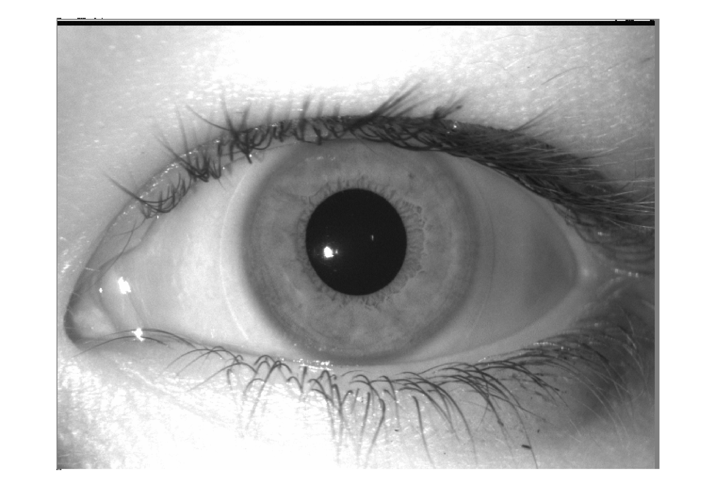

1. Blur the iris image

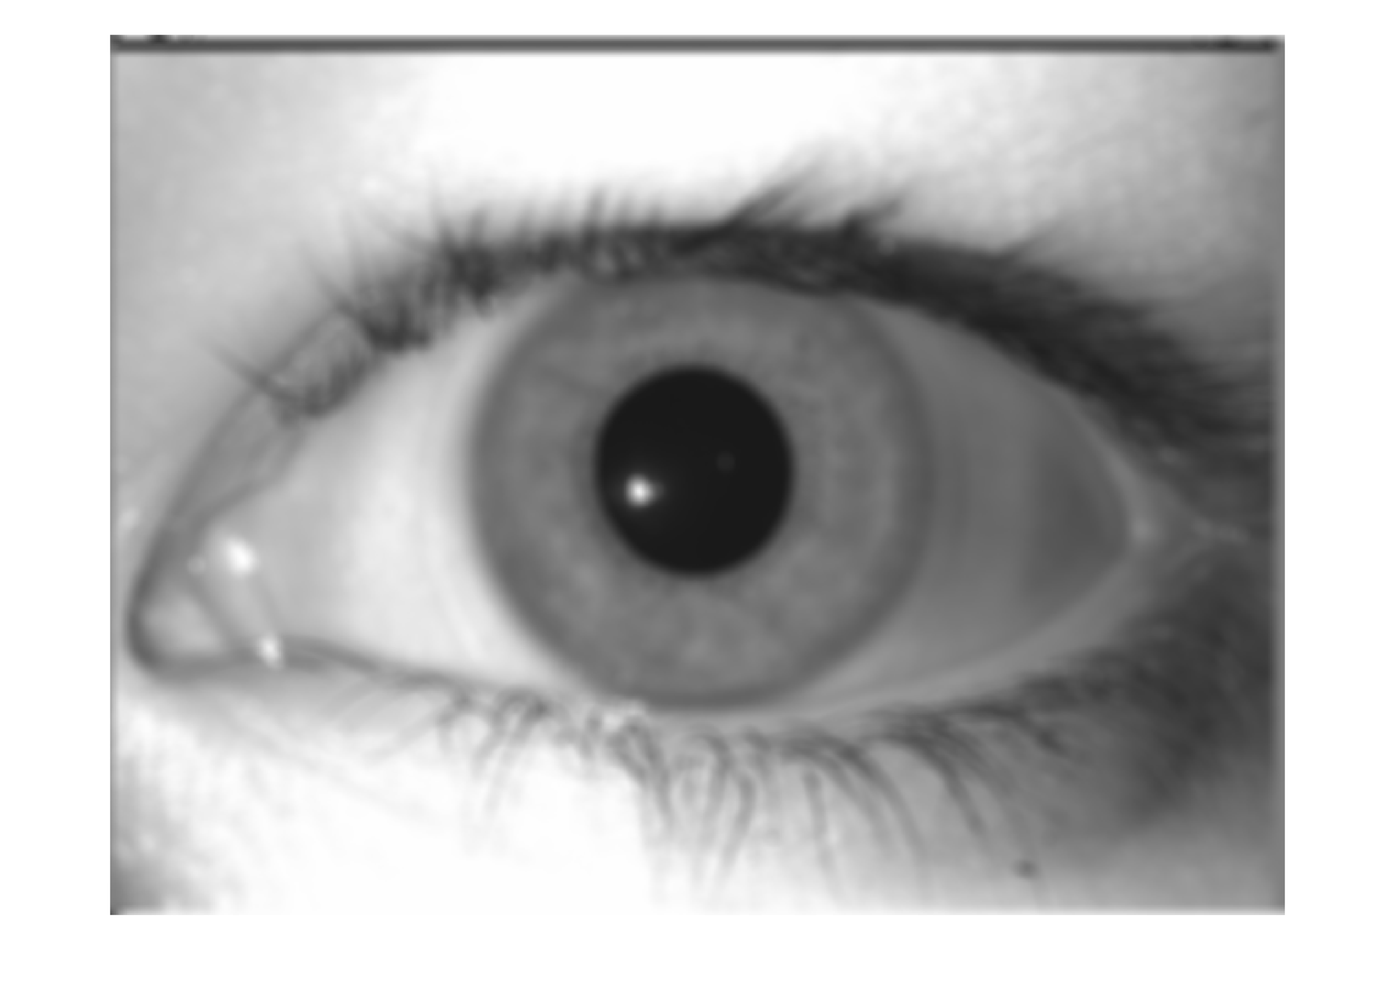

1. Project pupil into a binary image based the special gray scale level of pupil
2. Find edges using Canny filter

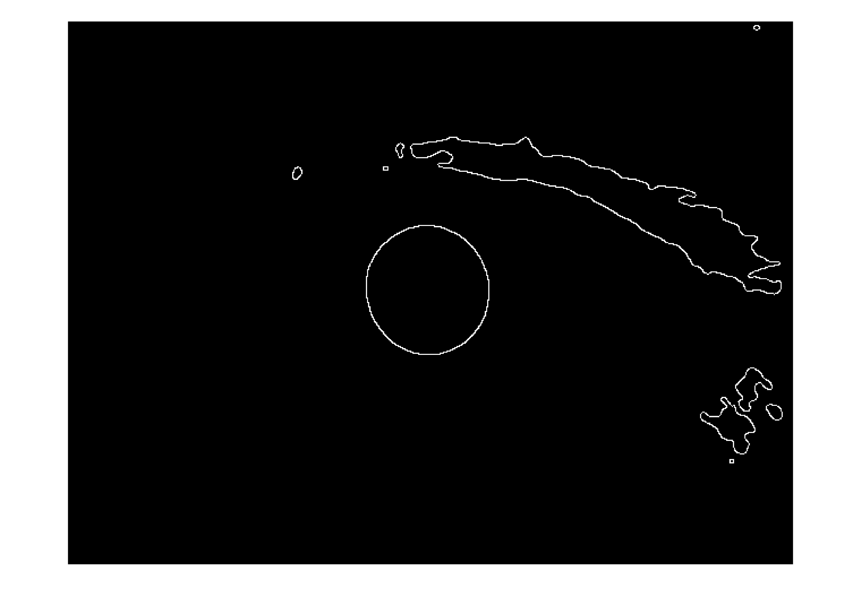

1. Using Hough transform to find the center and radius of of the pupil



1. Project limbic boundary roughly into a binary image based the gray scale level



1. Extract the edges using Canny filter

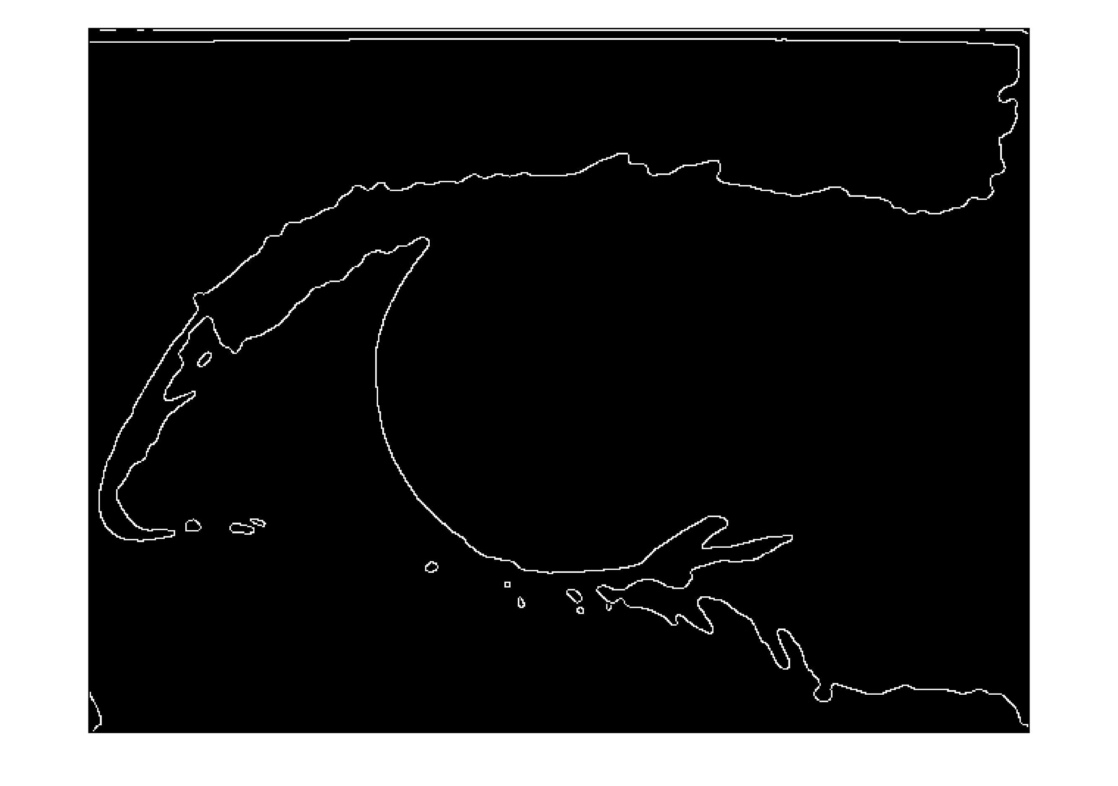

1. Using Hough transform to find the center and radius of of the limbic boundary



The MATLAB source code and result pictures are in the folder: Iris Segment Method 1 (p.s. using run_iris.m to run the iris segmentation program)

**Method 2:**

1. Read an iris image



1. Use Gaussian Filter to blur

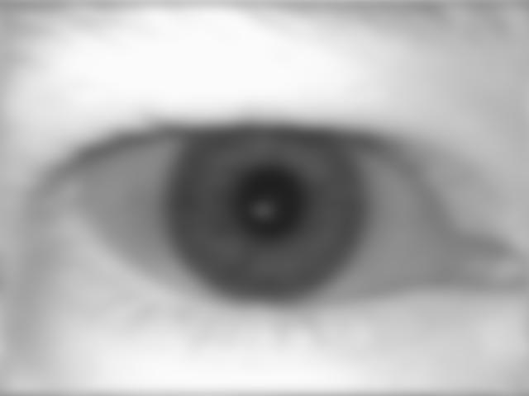

1. Find the interested area



1. Transform the interest area to binary image and find the center of the pupil



1. According to the Daugman`s operator to locate the boundary

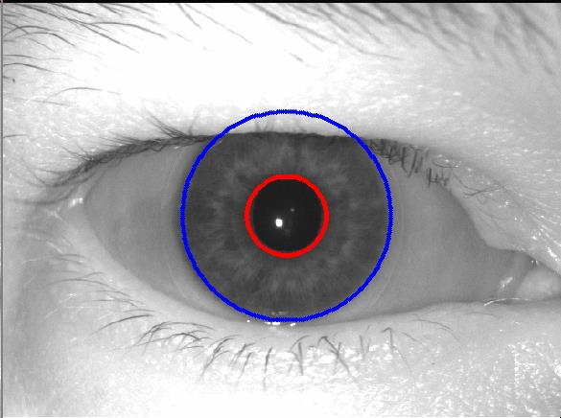

The MATLAB source code and result pictures are in the folder: Iris Segment Method 2